Aim: To upload data on Thingspeak cloud manually. Steps:

1. Go to Google and search for Thingspeak.
2. If you are new to Thingspeak, Do sign up and make sure you are on your Channel page.
3. Click on the NEW CHANNEL button (Green colour) and create a new channel.
4. Enter a channel name, any description of your choice, and make sure one field is selected or ticked and give that field a name of your choice. Click on save.
5. Now in the private view, make sure you see a graph (empty).
6. Now click on API KEYS tab, scroll down to find API requests section and in that copy the link of Write a Channel Feed and paste it in the Address bar of your browser. And press enter to get a blank screen with a number which indicates the number of data uploaded manually.

Following is the example link: https://api.thingspeak.com/update?api_key=6WEDQNFN3GBKNCQ3&field1=0

1. Suppose you want to change the data to be entered in the graph, just change the

=0 to any value of your choice in the link.

Here is the link, where we had changed 0 to 40. https://api.thingspeak.com/update?api_key=6WEDQNFN3GBKNCQ3&field1=40

9. As a result, to see the visualization (graph), goto the private view and see the graph.

Aim: To update readings to Thingspeak from Arduino using Tinkercad.

Steps:

1. Click on the NEW CHANNEL button (Green colour) and create a new channel.
2. Enter a channel name, any description of your choice, and make sure one field is selected or ticked and give that field a name of your choice. Click on save.
3. Now in the API Keys tab copy the Write API Key and Paste it in your program

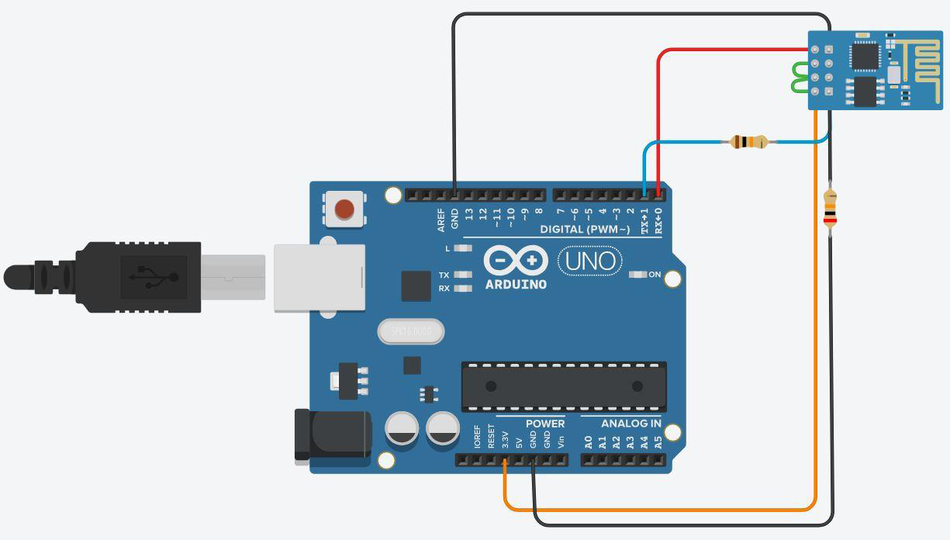

PROGRAM:

void setup() { Serial.begin(115200);

delay(1000);

//if you want thingsspeak through tinkercad use simulator wifi as your ssid Serial.println("AT+CWJAP=\"Simulator Wifi\",\"\"\r\n");

delay(3000);

}

void loop() {

{

Serial.println("AT+CIPSTART=\"TCP\",\"api.thingspeak.com\",80\r\n"); delay(5000);

int len = 57;//length of line 15 Serial.print("AT+CIPSEND="); Serial.println(len);

delay(10);

Serial.print("GET /update?api_key=ZRGGNNASXTIB4M3B&field1=120 HTTP/1.1\r\n"); // Change the field value to see the variations in the data

delay(100); Serial.println("AT+CIPCLOSE=0\r\n"); delay(6000);

}

}

NOTE:

1. TEXT IN RED COLOUR IS YOUR WRITE API KEY
2. Make sure you see your Serial Monitor and check if Data is sent to Thingspeak.
3. To check result about data upload, go to thingspeak, click on private view and see the graph.

**Practical No. 12 B**

Aim: To interface Temperature sensor and ESP8266 with Arduino and update temperature reading to Thingspeak.

Steps:

1. Click on the NEW CHANNEL button (Green colour) and create a new channel.
2. Enter a channel name, any description of your choice, and make sure one field is selected or ticked and give that field a name of your choice. Click on save.
3. Now in the API Keys tab copy the Write API Key and Paste it in your program

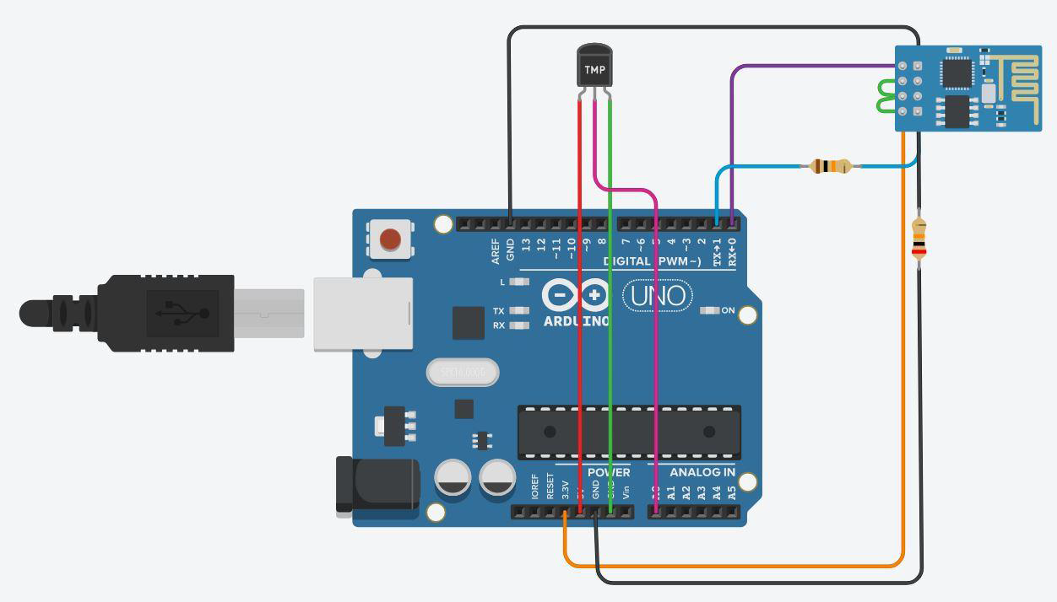

PROGRAM:

void setup() { Serial.begin(115200); delay(1000);

Serial.println("AT+CWJAP=\"Simulator Wifi\",\"\"\r\n"); delay(3000);

}

void loop() {

{

int sensorValue = analogRead(A0);

float volt = (sensorValue/1020.0) * 4.9; //Volts float tempC = (volt -0.5) * 100; //Celcius Serial.println(tempC);

Serial.println("AT+CIPSTART=\"TCP\",\"api.thingspeak.com\",80\r\n"); delay(5000);

int len = 65; Serial.print("AT+CIPSEND="); Serial.println(len);

delay(10);

Serial.print("GET /update?api_key=EDLBQ1UJ9ZLNXD57&field1=" + String(tempC)

+" HTTP/1.1\r\n");

delay(100); Serial.println("AT+CIPCLOSE=0\r\n"); delay(6000);

}

}

NOTE:

1. TEXT IN RED COLOUR IS YOUR WRITE API KEY
2. Make sure you see your Serial Monitor and check if Data is sent to Thingspeak.
3. To check result about data upload, go to thingspeak, click on private view and see the graph.

# Practical No. 12 C

Aim: To interface LDR sensor, LED and ESP8266 with Arduino and update light intensity values to Thingspeak and tweet “LIGHT ON” message on tweeter when light intensity value is less than 300.

Steps:

1. Click on the NEW CHANNEL button (Green colour) and create a new channel.
2. Enter a channel name, any description of your choice, and make sure one field is selected or ticked and give that field a name of your choice. Click on save.
3. Now in the API Keys tab copy the Write API Key and Paste it in your program

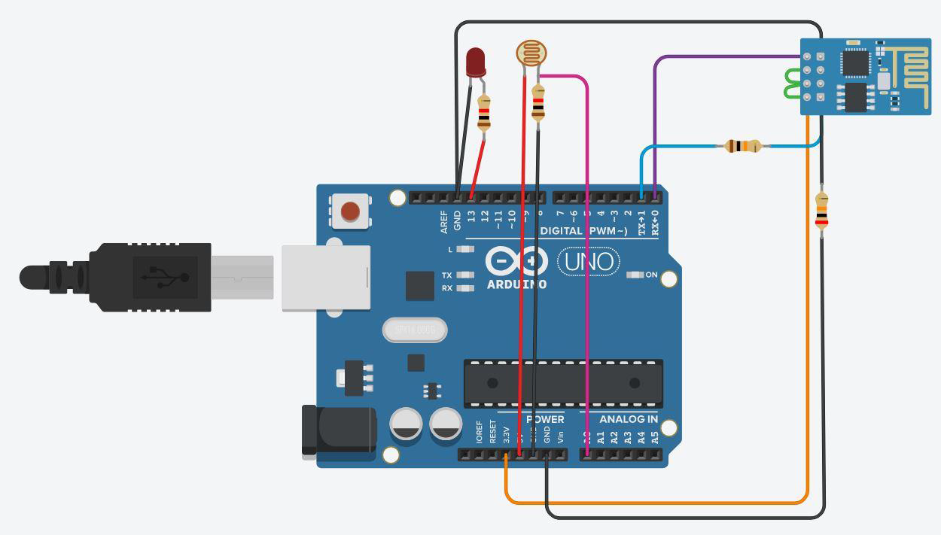

PROGRAM:

int ldr=A0;//Set A0(Analog Input) for LDR. int value=0;

void setup()

{

Serial.begin(115200); pinMode(13,OUTPUT); delay(1000);

Serial.println("AT+CWJAP=\"Simulator Wifi\",\"\"\r\n"); delay(3000);

}

void loop()

{

{

value=analogRead(ldr);

Serial.println("LDR value is :"); Serial.println(value); if(value<300)

{

digitalWrite(13,HIGH);

}

else

{

digitalWrite(13,LOW);//Turns the LED OFF in Light.

}

Serial.println("AT+CIPSTART=\"TCP\",\"thingspeak.com\",80"); delay(5000);

int len = 65; Serial.print("AT+CIPSEND="); Serial.println(len);

delay(10);

Serial.print("GET /update?api_key=6WEDQNFN3GBKNCQ3&field1="+ String(value)

+" HTTP/1.1\r\n");

delay(100); Serial.println("AT+CIPCLOSE=0\r\n"); delay(6000);

}

} NOTE:

1. TEXT IN RED COLOUR IS YOUR WRITE API KEY
2. Make sure you see your Serial Monitor and check if Data is sent to Thingspeak.
3. To check result about data upload, go to thingspeak, click on private view and see the graph.
4. Once you finish doing the above steps go back to Thingspeak and next to the CHANNELS tab , click on the APPS tab and select React option.